Project Design Phase-II
Data Flow Diagram & User Stories

Date | 20-02-2026
Team ID | LTVIP2026TMIDS24612
Project Name | Dog breed identification using transfer learning
Maximum Marks | 4 Marks

Data Flow Diagrams:
A Data Flow Diagram (DFD) illustrates how data moves within the Dog Breed Identification platform. It captures how users upload dog images to the system, how information flows between different components, and where the image data is processed and stored.
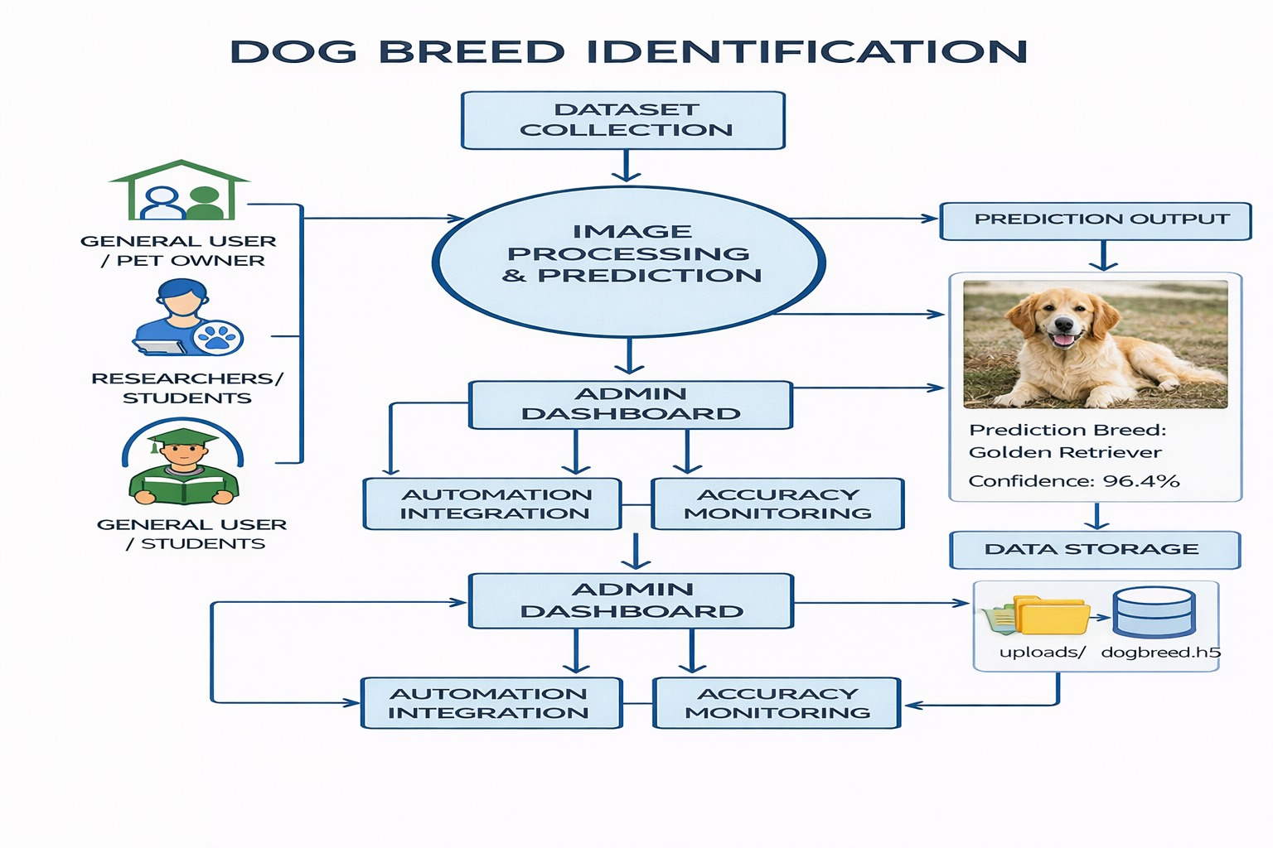
User Stories
User Story Table – Dog Breed Identification
User Type | Functional Requirement (Epic) | User Story / Task | Acceptance Criteria | Priority | Release
User | Image Upload | As a user, I can upload an image of a dog. | Image is uploaded successfully and displayed. | High | Sprint-1
User | Image Processing | Image is resized and processed correctly. | Image is resized to 224×224 and normalized properly. | Medium | Sprint-2
System | Model Prediction | As a system, I can classify the uploaded image using transfer learning. | Prediction result is accurate and displayed. | High | Sprint-1
User | View Prediction Result | As a user, I can view the predicted dog breed. | Predicted breed name is clearly visible on screen. | Medium | Sprint-2
Developer | Model Training | As a developer, I can train the model using a dataset of dog breed images. | Model achieves acceptable validation accuracy. | High | Sprint-2
Developer | System Testing | As a developer, I can test the system using different dog images. | System provides correct breed predictions. | High | Sprint-2
User | System Usability | As a user, I can easily use the system without technical knowledge. | Interface is simple, responsive, and easy to use. | Medium | Sprint-2

